Effective Date: 11/02/2015
Revision Date:

Policy Subject

Employee Referral Policy

Policy Statement:
This program is designed to help source top talent, build diversity, find candidates for hard-to-fill positions, decrease cost per hire, and decrease turnover and improve company culture.

To encourage employees to refer new talent for positions within Hartman, the referring employee will receive a monetary reward of $50.00 in the form of a “Gold Coin” for each referral that results lead to a successful completion of the assessments and interviews with a representative of the company. If the referral is selected for hire; the referee (employee) will receive a monetary award of $1,000. The $1,000 reward will be paid quarterly in increments of $250.00. The employees first payment will be administered upon the completion of the referrals 60day evaluation period.

- Eligibility:

Referring Employee

- Who is eligible for reward: Most active full- and part-time employees are eligible for reward.
- Who is NOT eligible for reward: Employees in the HR department, Management Level employees and Business Unit Director Employees. Hartman contract employees will not be eligible for the monetary award of $1,000 but can receive a Gold Coin if their referral is interviewed.

Candidate (Referral)

- Candidate must be: Submitted via email to the HR Director (Kimberly Strickland) and copy the Corporate Recruiter (Aisha Blackman) with the subject reading- Employee Referral and Candidates name.
- The following Candidates are not eligible: Individuals that are actively engaged in the Hartman selection process or Interns being hired on as permanent employees.
- Process:

Before referring a candidate, employees should consider his or her:

- work experience
- educational background
- employment record
- possible fit for position and Hartman’s culture

Employees must follow the referral process in order to be eligible for a referral reward:

- Employee must email the referrals resume and/or contact information to the HR Director and copy the Corporate Recruiter listing what open position in which they are being referred to.
- A phone screening will be scheduled to discuss their resume and position in which they were referred for.
- The referral will be contacted via phone within in 24 hours of receipt of their resume to the HR Director.
- Employees will be made aware of their referral’s status only if the referred candidate is being asked to be interviewed. At this point a “Thank you” card and Gold Coin will be administered to all employees whose referral has successfully completed the assessments and has been asked to interview.
- The new hire (candidate) must successfully complete their 60day evaluation period for the employee to begin to receive payments of the $1,000.

- Payment:

At the time the offer letter is sent out to the referral a “referral form” will be completed by the Corporate Recruiter and submitted to payroll upon successful completion of the 60 day evaluation period.

“The referral should notate on the application the name of the employee that referred them.”

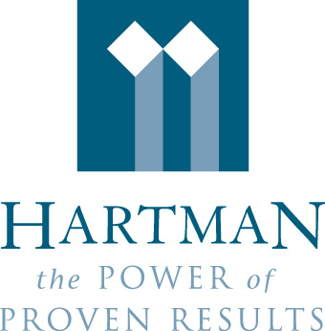
Texas REIT Manager, LLC
EMPLOYEE REFERRAL FORM

Date: ___________________________________________________________

Employee name: _________________________________________________
Name of applicant referred: _________________________________________
Position: ________________________________________________________
Start date: _______________________________________________________
60 day conversion date: ____________________________________________

__________________________________________
Signature (Employee)

Certification of Referral

I certify that my application for employment was submitted to the Human Resources Dept of Hartman Management at the recommendation of the above named employee.

___________________________________________ ______________
Signature (Applicant) Date

For Human Resources Use Only

Position Filled: Department:

Start Date: ( ) Full-Time/Exempt $1000
( ) Part-Time

60 Days (Date)

Amt. Due: $1000.00
Date to Payroll:

